**TOPIC ONE: INTRODUCTION**

Macroeconomics is the branch of economics that studies the behavior and performance of an economy as **a whole.….**

It is concerned with the analysis of aggregate economic behavior of all economic units in the economy i.e. the overall outcome or consequences of all individual actions of the household sector, business sector, the government sector and the external sector. The study therefore focuses on economic aspects (activities) that affect the economy as a whole with a view to understanding the interaction between economic aggregates such as [**national income**](http://en.wikipedia.org/wiki/Measures_of_national_income_and_output)**,** [**employment**](http://en.wikipedia.org/wiki/Employment) **and** [**inflation**](http://en.wikipedia.org/wiki/Inflation).

Macroeconomics studies not household income but *national* income, not individual prices but the *overall* price level. It does not analyze the demand for labor in the automobile industry but instead total employment in the economy.

**Microeconomics on the other hand** is a branch of economics that studies the behavior of individual economic units such as households, firms and small groups. Microeconomics answers questions such as: (i) how to produce (how does the firm combine different inputs to produce a given level of output? (ii) How much to produce (How does the firm determine how much to produce under given market conditions?)(iii) When to produce ( when does the firm take decisions to vary output?) and (iv) For whom to produce ( who buys the firm’s output- where is the market, and how do changes in the price of outputs affect the market for the output?)

Both microeconomics and macroeconomics are concerned with the decisions of **households and firms**. Microeconomics deals with individual decisions; macroeconomics deals with the sum of these individual decisions. ***Aggregate***is used in macroeconomics to refer to sums. When we speak of **aggregate behavior**, we mean the behavior of all households and firms together. We also speak of aggregate consumption and aggregate investment, which refer to total consumption and total investment in the economy, respectively.

The most important macroeconomic problems-[**unemployment**](javascript:pop_dsp('pop_gls.pl?k=unemployment',500,400))**,** [**inflation**](javascript:pop_dsp('pop_gls.pl?k=inflation',500,400))**, and stagnant** [**production**](javascript:pop_dsp('pop_gls.pl?k=production',500,400))--relate to the three macroeconomic goals of

1) Full employment. This is a situation in which all available resources in the economy are employed to produce goods and services.

2) Price [stability](javascript:pop_dsp('pop_gls.pl?k=stability',500,400)). The goal of the nation is to keep its inflation rate as low as possible maintaining price stability. Inflation occurs when there is an increase in the overall price level, which can reduce the purchasing power of consumers.

3) [Economic growth](javascript:pop_dsp('pop_gls.pl?k=economic%20growth',500,400)). This refers to an increase in the full production of output level of a nation overtime.

**However,** it is rare for a country to achieve all its macroeconomic goals at the same time. Frequently conflicts can appear between the different goals, as a result choices might have to be made about which goals are to be given greatest priority but this varies from one country to another since needs of different countries will differ according to their stage of economic development.

The macroeconomic conflicts include,

1. **Inflation Vs Unemployment**.

As the economy grows, unemployment falls, resources are all nearly used up and to hire more labor, firms must offer higher wages, wages rise, firm’s costs rise and there is inflation As the rate of unemployment falls, labour shortages may cause an increase in wage inflation leading to higher unit labour costs

• When an economy is booming, so does the derived demand for and prices of components and raw materials – this leads to higher costs

• Rising demand and falling unemployment can lead to suppliers raising prices to increase their profit margin

**2) Economic growth Vs inflation**.

An overheating economy may suffer accelerating inflation because of rising demand and an increase in the prices of raw materials.

**3) Economic growth Vs balance of payment**

Strong GDP growth fuelled by high levels of consumer demand might lead to a worsening balance of trade balance especially when the marginal propensity to ***import is high***.

Unemployment, commonly measured by the average [unemployment rate](javascript:pop_dsp('pop_gls.pl?k=unemployment%20rate',500,400)), indicates the portion of the economy's total resources that are not being used for production. Inflation, measured by the [inflation rate](javascript:pop_dsp('pop_gls.pl?k=inflation%20rate',500,400)), indicates whether the average level of prices are rising, falling, or remaining stable. Problems related to aggregate production are measured by [gross domestic product](javascript:pop_dsp('pop_gls.pl?k=gross%20domestic%20product',500,400)), especially relative to [potential gross domestic product](javascript:pop_dsp('pop_gls.pl?k=potential%20gross%20domestic%20product',500,400)).

The modern study of macroeconomics is an explanation of and remedy for, economic problems through economic policies.

**The two most common macroeconomic policies are**

* [Fiscal policy](javascript:pop_dsp('pop_gls.pl?k=fiscal%20policy',500,400)) ,this seeks to stabilize the business cycle using government expenditures and taxes.
* [Monetary policy](javascript:pop_dsp('pop_gls.pl?k=monetary%20policy',500,400)), this seeks to stabilize the business cycle using the [money supply](javascript:pop_dsp('pop_gls.pl?k=money%20supply',500,400)) and [interest rate](javascript:pop_dsp('pop_gls.pl?k=interest%20rate',500,400))s.

**MACROECONOMIC THEORIES**:

Scientific theories seek to explain phenomena associated with the macro economy. Macroeconomic theories provide policy recommendations intended to improve the performance of the economy and to correct macroeconomic problems. Macroeconomic theories are scientific theories that help to explain the workings of the [macro economy](javascript:pop_dsp('pop_gls.pl?k=macroeconomy',500,400)). Specifically, they explain how and why the level of [gross domestic product](javascript:pop_dsp('pop_gls.pl?k=gross%20domestic%20product',500,400)) changes, and the direct implications for [unemployment](javascript:pop_dsp('pop_gls.pl?k=unemployment',500,400)) and [inflation](javascript:pop_dsp('pop_gls.pl?k=inflation',500,400)), as well. Other dimensions of the macro economy, are [interest rate](javascript:pop_dsp('pop_gls.pl?k=interest%20rate',500,400))s, [consumption expenditures](javascript:pop_dsp('pop_gls.pl?k=consumption%20expenditures',500,400)), the [price level](javascript:pop_dsp('pop_gls.pl?k=price%20level',500,400)), [investment expenditures](javascript:pop_dsp('pop_gls.pl?k=investment%20expenditures',500,400)), [saving](javascript:pop_dsp('pop_gls.pl?k=saving',500,400)), and [taxes](javascript:pop_dsp('pop_gls.pl?k=taxes',500,400)).

**MACROECONOMIC PROBLEMS:**

The primary problems are unemployment, inflation, and stagnant growth. Macroeconomic theories are designed to explain why these problems emerge and to recommend corrective policies.

Macroeconomic problems arise when the [macro economy](javascript:pop_dsp('pop_gls.pl?k=macroeconomy',500,400)) does not satisfactorily achieve the goals of [full employment](javascript:pop_dsp('pop_gls.pl?k=full%20employment',500,400)), [stability](javascript:pop_dsp('pop_gls.pl?k=stability',500,400)), and [economic growth](javascript:pop_dsp('pop_gls.pl?k=economic%20growth',500,400)). [Unemployment](javascript:pop_dsp('pop_gls.pl?k=Unemployment',500,400)) results when the goal of full employment is not achieved. [Inflation](javascript:pop_dsp('pop_gls.pl?k=Inflation',500,400)) exists when the economy falls short of the price stability goal. These problems are caused by too little or too much [demand](javascript:pop_dsp('pop_gls.pl?k=demand',500,400)) for gross [production](javascript:pop_dsp('pop_gls.pl?k=production',500,400)). Unemployment results from too little demand and inflation emerges with too much demand. Stagnant growth means the economy is not adequately attaining the economic growth goal.

### **1) Unemployment**

Unemployment arises when [factors of production](javascript:pop_dsp('pop_gls.pl?k=factors%20of%20production',500,400)) that are willing and able to produce goods and services are not actively engaged in production. It also means that the economy is not attaining the macroeconomic goal of full employment. Unemployment is a macroeconomic problem because:

* Less output is produced and thus the economy is less able to address the [scarcity](javascript:pop_dsp('pop_gls.pl?k=scarcity',500,400)) problem.
* The owners of unemployed resources receive less income and thus have lower [living standard](javascript:pop_dsp('pop_gls.pl?k=living%20standard',500,400))s.

### **2) Inflation**

Inflation arises when the average [price level](javascript:pop_dsp('pop_gls.pl?k=price%20level',500,400)) in the economy consistently and persistently increases. In other words, prices generally rise from month to month and year to year and the economy does not attain the stability goal.

Inflation is an average increase in prices, with some prices rising more than the average, some rising less, and some even declining. As such, not every member of society is likely to experience exactly the same inflation. Inflation is a problem because:

* The [purchasing power](javascript:pop_dsp('pop_gls.pl?k=purchasing%20power',500,400)) of financial assets such as [money](javascript:pop_dsp('pop_gls.pl?k=money',500,400)) declines, which reduces financial wealth and lowers living standards.
* Greater [uncertainty](javascript:pop_dsp('pop_gls.pl?k=uncertainty',500,400)) surrounds long-run planning, especially the purchase of durable and [capital](javascript:pop_dsp('pop_gls.pl?k=capital',500,400)) goods.
* Income and wealth can be haphazardly redistributed among sectors of the economy and among resource owners.

### **3) Stagnant Growth**

The problem of stagnant growth arises because the supply of [aggregate production](javascript:pop_dsp('pop_gls.pl?k=aggregate%20production',500,400)) is not increasing at a desired rate or is even declining. An increase in the total production of goods and services is generally needed to keep pace with an increase in the population. Stagnant growth exists if total production does not keep pace, implying that the macroeconomic goal of economic growth is not attained.

Stagnant growth is explained by the quantity and quality of the resources used for production.

**Business cycles:**

Refers to short term fluctuations of actual real GDP.The term business cycle refers to economy-wide fluctuations in production or economic activity over several months or years. These fluctuations occur around a long-term growth trend, and they typically involve shifts over time between periods of relatively rapid economic growth (an [expansion](http://en.wikipedia.org/wiki/Economic_expansion) or [boom](http://en.wikipedia.org/wiki/Economic_boom)), and periods of relative stagnation or decline (a contraction or [recession](http://en.wikipedia.org/wiki/Recession)).

Business cycles are usually measured by considering the growth rate of output. Despite being termed as [cycles](http://en.wiktionary.org/wiki/cycle), they do not follow any predictable periodic pattern.

**Diagram of business cycles**

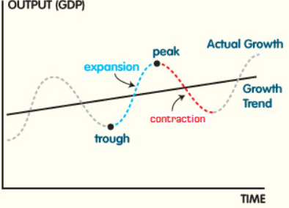

**Phases of business cycles**

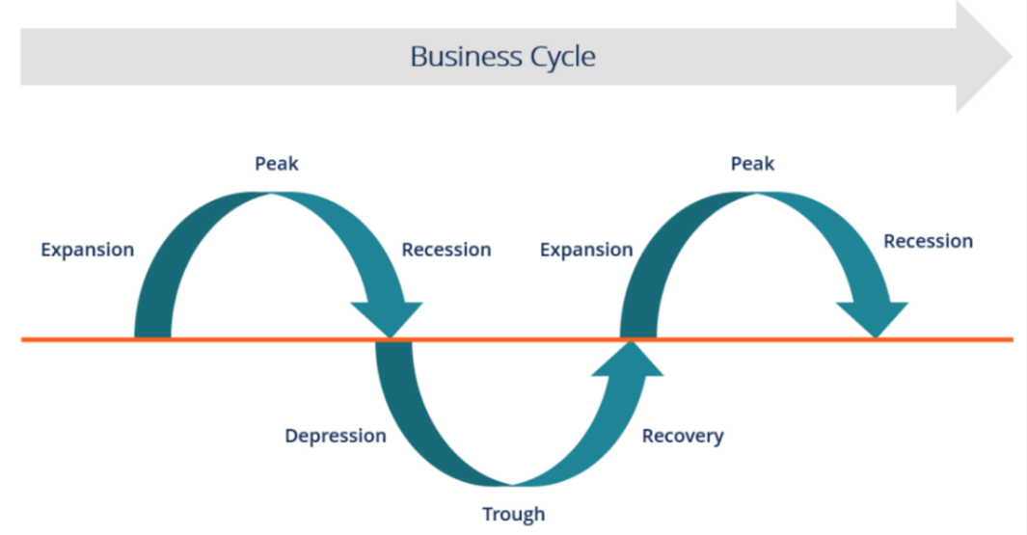

**Trough**

***This is the lowest turning point of a business cycle***. When the economy is at a trough, there is high unemployed of resources and prices are low; the level of output is low in relation to the economy's capacity to produce. There is therefore a significant amount of unused productive capacity. Business profits are low or negative for some individual companies. New investments are risky because firms lack confidence in the immediate future.

**Recovery**

***This is the period of expansion*** and during this period old equipment is replaced and the existing unused capacity and unemployed labor are reemployed. Employment, income, and consumer spending all begin to rise and expectations become more favorable due to increased sales and profits. Investments that once seemed risky may be undertaken as the business climate starts to improve.

**Peak**

***A peak is the top of a cycle.*** At the peak, existing capacity is used to a high degree; labor shortages may even develop especially for labor with key skills. There could be shortages of essential raw materials as well. As shortages develop in more and more markets, a situation of general excess demand develops. Costs rise, but because prices rise too, business remains profitable.

**Recession**

***A recession, or contraction, is a downturn in economic activity***. It commonly defined as a fall in output for two successive quarters. Demand falls and as a result, production and employment fall too. As employment falls so do households' incomes. Profits reduce and some firms encounter financial difficulties. Investments that looked profitable with the expectation of continually rising demand now appear unprofitable. It may not even be worth replacing capital goods as they wear out because unused capacity is increasing steadily. A recession that is deep and long lasting is often known as a depression.

**Other terms to consider**

**Booms and Slumps**

The entire falling half of the cycle is a slump, and the entire rising half is a boom.